READING LESSON NOTES
(FOR BEGINNERS AND P.1- TERM 1 2016)

Note: These lesson notes can be useful to learners from Baby class to Primary Two.

Step/ Lesson 1

Teach letter sounds (Let the teacher choose how many sounds pupils can manage. This depends on class ability and level.)

a | b | c | d | e | f | g | h | I | j | k | l | m
n | o | p | q | r | s | t | u | v | w | x | y | z

Step/Lesson 2
Teach vowel sounds.

a e i o u û

Step /Lesson 3
Teach consonant sounds.

b | c | d | f | g | h | j | k | l | m | n
p | q | r | s | t | v | w | x | y | z

Step/Lesson 4
Join the learnt vowels and the consonants and form English words.

in on out of ûp as fly it un owl ass at my

Step 5
Join all the consonants learnt with sound a to form syllables.

ba | ca | da | fa | ga | ha | ja | ka | la | ma
na | pa | ra | sa | ta | va | wa | ya | za

Write the syllables learnt, read them and add on one consonant. Form three letter words.

ba-n ba-t ca-n da-n
ba-g ba-m ca-t da-m

Step 7
Use the syllables of sound a and form vernacular words.

ma-ta | sa-la | la-ga | sa-ka | a-ma-ta
ma-ka | ba-la | pa-pa | la-ba | a-baa-na
maa-ma | taa-ta | jaa-ja | Ka-ba-ka | ba-na-na

Step 8
Teach phrases with words learnt previously.

a man and a bag a van and a can
a cat and a rat
a car and a mat
a dam and a banana
a man and a lad.

Step 9
Teach pupils to construct sentences well punctuated from the phrases.

A man has a car. A cat has a rat. Matata has a fan. Maama has a mat. Tat has a bag
Kabaka has a banana.

Be creative, give the words from phrases and sentences and form a story.

Matata is a boy. Matata has a bag, a ban, a cat, a fan and a toy cat. Matata and
Maama sit on the mat and look at the cat.

Question
Who has a bag? Matata has a bag.
Who sits on the mat? Matata andMaama sit on the mat.

Step 11
Write consonants that you are able to teach and accompany them with sound e .

Form syllables of “e”

be | ce | de | fe | ge | he | je | ke | le
me | ne | pe | re | se | te | ve | we | ye

Step 12
Join the learnt syllables and form word

bo-re | de-be | fe-ne | we-re | g-re
ke-re | de-ne | ke-ne | se-se | pe-re
se-re | me-re | kw-le | e-me-re | e-de-ne

Step 12
Copy the syllables learnt. Add on one or two consonants and form correct English
words.

be-d be-t de-n se-t ge-t ve-s-t me-n we-t
te-ll re-s-t te-s-t he-n le-g ne-s-t pe-s-t

Use the learnt words with sound a and sound e to form/ construct sentences.

Men have beds. Kapere has a vest. A hen has eggs. Get the set.
The ten eggs are here.
They are seven men. Eddebelinoddene. Enommere.
Maama nessere. Kaperene ffene

Note: After the teacher mastering what the sequence for reading is that is; sound syllable word phrase sentence the story. Teach allthe consonant vowels stated in Step 2.

Step 15
Teaching double letter sounds.

ee [i]
Words with ee”

Teacher and pupil can add on the list. Leave our words that dont have that sound even if they have the letters.
Form sentences using the words.
Use the sentences and form a simple story.

Other double letter sounds
oo ai al le ou oa er ir or ea

Step 16
Teach double consonants
Sort them according to how they rhyme.
Group I Group II Group III
br | gr | ch | st | mb | ns | nk
cr | pr | sh | ng | mp | nd | ns
dr | pr | ck |  | nf | nt
gr | tr | ry |  | ny | nj | nv
fr |  | th |  | nz

Str nty tch spr spl scr sch

Accompany the sound with possible vowels i.e

stra | stre | tsri | stro | strû
Form words
stra-p srtre-tch stre-ngth |  | stri-p stri-ct stro-ng | stro-nger stro-ke stru-ck

Use these words to form sentences.
Father is so strict.
He suffered from a stroke. Makula is stronger than Ali.
I donot havethe strength to walk. We eat food tobe strong
Other activities can be
a) Use some words to consult meaningful and correct sentences.
b) Form words
 | ap | a)
 | oke | b)
str | ike | c)
 | uck | d)
 | ip | e)

Continue following the steps and complete all the sounds.
P.1 READING LESSON NOTES TERM II 2016

Exercise 1
Reading syllables with sound a
Lesson 1
Week 1

Syllables: ba ca da fa ga ha ja ka la ma na pa ra sa ta va wa ya za
Lesson 2
Words: ba – g fa  t ra  g ca  t ta – p ja – m
ma t wa-sp da d etc.

Lesson 3
Blending:-
d t
ba g ma p ll n
nd st etc.

lesson 4
Dictation of words learnt.
Completing sentences
1. The man has a 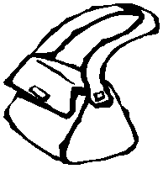

2. The cat ran after the

3. This

is bad.

4. The
is as black as charcoal.

5. The

6. The fat man has a

7. This

8. My dad bought a
_ is in jam.  .
_ is black.
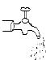

Exercise II
Using syllables with sound e

Syllables

Words
be ce de fe ge he je ke le
me ne pe re se te ve we ye ze

be – d be-g ce-ll te-n se-t re-d ne-t me-t ne-st ve-st re-st che-st we-t we-ll we-d se-ll etc.

Puzzles.
b | e | d |  | n
e | a | s | t | e
s |  |  |  | s
t | e | n |  | t

Across down

1.
2.
3.
1.
2.
3.

Sentences.
1. The hen has ten

2. His red
is on the bed.

3. Seven birds went into their
4. The 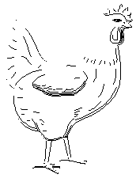 _ lays eggs for gentlemen.

5. The men are in the

Exercise 1
reading syllables with sound  I
Week 2

Syllables

bi ci di fi gi hi ji ki li
mi ni pi ri si ti vi wi yi zi
Words
bi-g | ci-ty | fi-sh | di-g | di-p | pi-g | vi-m
ti-n | ti-p | mi-lk | ri-m | pi-t | pi-n | zi-p
gi-ve | hi-ss

Puzzles. Across down

1.
2.
3.
4.
1.
2.
3.
4.

Sentences.
p |  | t |  | n
 |  |  | n | k
n |  | p |  | t
 |  |  |  | n

1. The

has big ears.

2. There is a
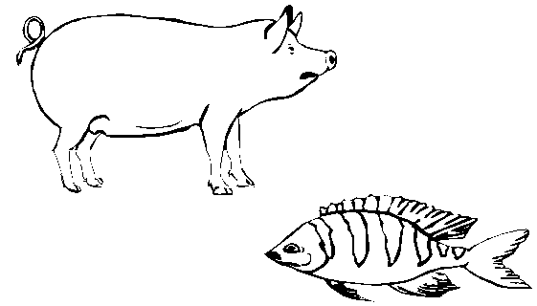

in the river.

3. The baby is crying for

4. The boy steppes on a sharp

5. He has a of niddo milk.

6. The _ is full of ink.

Exercise 2
reading syllables with sound O

Syllables
bo co do fo go ho jo ko lo
mo no po ro so to vo wo yo zo

Words
Bo-x | do-g | so-ng | po-t | ro-ck | ro-t | ro-pe
To-p | fo-x | lo-g | lo-ck | lo-ng | ho-t | ho-st
Ho-le | jo-g | so-t | so-rry | sto-p | vo-te | etc

Blending exercise.
ne
bo x nd ss

t to p ss

Sentences
1. The is on the table.

2. The
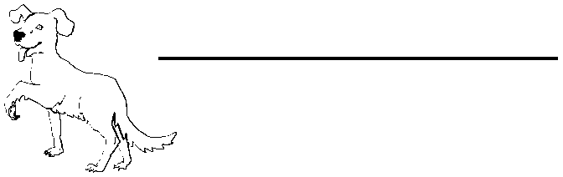

is eating a bone.

3. She has a pair of

4. He has a 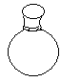
5. The girl is skipping a
_.

of water.
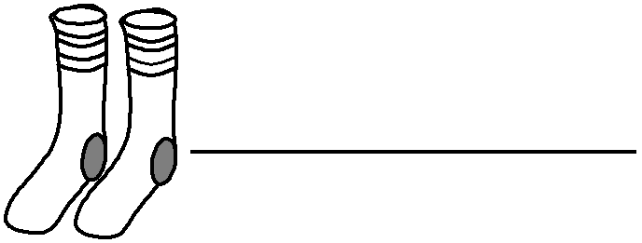

.

Dictation Exercise.
a) The frog is on the box.
b) The sun is very hot.
c) The boy jogs every day.

Exercise 2
Reading sound oa
boa coa foa goa hoa roa

Words.
boat | goat | roar | shoal | coat | float | oar
road | foal | toad | foam | soap

Fill in the missing letters
B at flo t fo _m f al r _ad sho l

Sentences
1. The goat is walking along the road.
2. A ball can float.
3. The boat and the oar are wooden.
4. A group of fish is a shoal.
5. Soap produces much foam.

Conversation:
Master: Where are you going my little goat?
Goat: I am going to the market to buy a new coat.
Master: A coat for a goat? Can a goat wear a coat?
Goat: People will laugh at a goat with a coat.

Exercise 1
Reading syllables with sound “u ( )”
Week 3

Syllables

Bu | cu | du | fu | hu | ju
lu | mu | nu | pu | ru | su | tu

Words
bi-g | ci-ty | fi-sh | di-g | di-p | pi-g | vi-m
ti-n | ti-p | mi-lk | ri-m | pi-t | pi-n | zi-p
gi-ve | hi-ss

Puzzles.
Across down

1.
2.
3.
1.
2.
3.

Sentences
s | t |  | c | k
 |  |  |  | s
m |  | s | t
 | s |  | n | g
 | e | n

Dictation exercise.

1. The bus is good.
2. The drum was cut.
3. A pig can grunt.
4. Run into the hut.
5. The man has a gun.
6. The sun is very hot.

Exercise 2
Reading syllables with sound “u”

Syllables

bu pu hu tru glu fu

Words

Bu-sh pu-sh hu-man pu-t hu-ge u-ni-for-m in-clu-de pru-ne pu-ll ju-ice fu-ll su-it

Blending exercise

1. The man is pushing a car.
2. The boy pulled a goat yesterday.
3. She put the book in her bag.
4. We put on uniforms to be smart.
5. An elephant is a huge animal.
6. We use a secateurs to prune plants.
7. A parson is a human being.
8. Include his name on the list.

Exercise 1

Sound OO”
Week 4

boo coo doo foo goo hoo loo moo noo poo roo soo too woo
zoo

Words

boo-t coo-l goo-se moo-n boo-m doo-m goo-d noo-n loo-k foo-d hoo-t roo-m coo-k foo-t poo-l soo-n too-l woo-d zoo broo-m etc Sentences, (dictation)
1. He is soon coming.
2. The room is open.
3. We eat food every day.
4. Mummy cooks food every day.
5. A young goose is a gooseling.
6. The moon is in the sky.

Rhyme

I see the moon and the moon sees me. God bless the moon and God bless me.

Week 5

Exercise 1

Wee bee dee fee gee hee

Kee lee mee nee pee ree see tee

Word

Wee-k fee-l kee-p pee-l see-k tee-th nee-d ree-d mee-t tee-n dee-p gee-se bee-f

Sentences

1. seven days make a ………………………….

2. I ……………… ..headache now.

3. We use knives to …………… matooke.

4. The ……………….are big birds.

5. I use a toothbrush to clean my ………… ..

6. You should ………… ..your pencils in the bag.

7. The meat of a cow is called …………………

Exercise 2

Sound ‘ea

bea cea dea fea gea hea

jea tea nea pea rea sea wea yea

Words

bea-n bea-r fea-r dea-r clea-r jea-ns lea-d gea-r yea-r wae-r lea-d rea-d
fill in the missing letters

s-a te_ cl _an hea__ l ad be_ ns r ad

Sentences (dictation)

1. We eat beasn and posho.

2. I fear to go near a lion.
3. She wears nice jeans.

4. You read your book every year.

5. My dear dad is near me.

Week 6
Exercise 1
Sound ‘ou
bou | cou | fou | lou | mou pou | sou | rou | shou | prou
Words

about loud ground out count pound shout found round proud sound mouse blouse
Read the sentences

1. The sound of a gun is loud.

2. I found a proud man.

3. The mouse ate her blouse.

4. It is bad to shout in class.

5. We can count loud.

Exercise II

Sound a: ’ar’

bar car dar far gar har mar par tar war yar

Words

bar hard smart cart mart start darling part star farm tar yard garden award fart
Sentences (dictation)

1. That boy is smart.

2. It has start to rain.

3. She farts in class.

4. There is a garden on the farm.

5. The star is in the sky.

6. A fraction is part of a whole.

7. We must work hard.

Week 7

Exercise 1

Sound ‘ir’

bir cir dir gir fir sir

Words

bird girl firm first circle dirty sir

Sentences (dictation)

1. The bird is flying.

2. The small girl was the first in class.

3. The classroom is dirty.

4. We go to learn at Sir Apollo Kaggwa primary School.

5. There is a shape of a circle on the chalkboard.

Exercise II

Sound ‘bl

bla ble bli blo blu blu words
black blade blaze blend

blast razorblade bleed bless

blink | block | blow | blue
blouse | blood | blame | cobbler
Sentences

Fill in the missing words

1. He cut his finger with a …………… ..

2. There is a lot of ……………… ..coming out of my nose.

3. God should ………………..old people

4. The chalkboard is ………………in colour.

5. A ………………………mends shoes.

6. Her ………………………..is blue in colour.

WEEK 8
Exercise I
Sound ‘cl
cla | cle | cli | clo | clu
Words
class | clean | clutch
clan | cloth | clown
clever | clock | clay
click | cluck | clip

